Department of Georgia Auxiliary News

### 

**October 2021**

**Volume 11, Issue 3**

# A Word from the President

# Z

### 

### 

The DEC Meeting will begin promptly at 6pm on Friday evening, the joint meeting with the Legion will begin at 8:30am Saturday morning and the Auxiliary meeting will begin at 9:30am A reminder to all District Presidents please bring your District Stars boards with you for the Parade of Stars to be held on Saturday Morning. See you then.

The Twin Stars Quilt will be drawn on Saturday morning please either mail your gold tickets to the Department prior to the Conference or bring them with you. Also, if your Unit has a trophy or plaque from 2019 please bring them to the conference so that the 2021 winners may retrieve them.

If there is anything my Leadership team and I can do for you and your unit or district, please don’t hesitate to contact us.

For God and Country

Susan Hall

Department President

Shoot for the Stars



HAPPY FALL!

Hard to believe 3 months has passed since our Convention in June. The time is just moving quickly along, and I have been busy traveling. In August we had our 100th year Celebration at the National Convention in Phoenix Arizona and what a celebration it was. It was great to be back together and seeing old friends and making new ones across the country. We congratulate our new National President Kathy Daudistel and look forward to her visit to our great state. The National Presidents theme this year is “Caring for those who care for others”, with a focus on care givers.

I have had the opportunity to visit 3 Districts so far this year and looking forward to visiting the other 9 Districts throughout my year. Department Leadership training has begun with the first held at Post 178 in Augusta on September 25. If you have the opportunity to attend one in your area, please do, things are always changing and we can never have enough knowledge, there is always something new to learn to help us forward the mission of the American Legion Auxiliary.

I am looking forward to getting together at our Fall Conference on October 22-24th in Duluth. My leadership team and I have been working to change things up this year, so if you can attend, please do it will be a new and exciting experience.

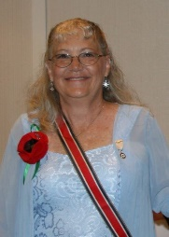

By Susan Hall, Department President

### 

### Inside This Issue

From President Susan Hall 1

Secretary 2

1st Vice President /Leadership 2

2nd Vice President 3

Historian 3

Chaplain 4

Quilt Raffle Dept Conference GOLD Tickets 4 Quilt Raffle 100 Presidents Blue Tickets 5

Calendar of Events 6

Inserts Membership Awards

By Pat Morgan, Dept. 1st Vice President

# Secretary

# 1st Vice President/ Leadership



By Patty Hawkins,

Fall has arrived and the weather is a little cooler. The leaves are turning and pumpkins are starting to appear everywhere. With season changes, it is always a breath of fresh air and a new adventure around the corner.

As we start this 2021 – 2022 year, we need to concentrate on Membership and working our programs. With Leadership Training you can always learn something new. So please plan on attending one or two. You can go out of your district attend one. We do a great job but there is so much more we can do. No one can do it by their self, so let’s see some Teamwork, we all something to offer. The list of Leadership workshop is in 1st VP Pat Morgan article.

If a unit is interested in getting on ALA MIS, we must have your form and the check in the Department by December 1, 2021. If you make any changes to who can use ALA MIS, you must send in the form with the 5 signatures. NO EXCEPTIONS.

REMINDER:

As checks go out for Memberships that are paid ONLINE, our checks have a time limit of 120 days ONLY (4 months). Please DO NOT hold the checks.

We have had a bad year and half with all of the Covid sickness and deaths, so let’s continue to pray for all the families that have had and continue to endure this evil disease. Pray for all our members we will overcome this.



**We hope to see everyone at Fall Conference October 22nd – 24th, in Duluth.**

**True friends are like diamonds — bright, beautiful, valuable and always in style.**



BE A SHINING

STAR

**Remember our fallen hero’s on**

**Patriots’ Day**

Summer is winding down and fall is here. As the seasons change, so must we. One way of achieving this is to develop your members. The goal of a good leader should be to **“train your replacement”**. Also, make your members feel needed. Your meetings need to be fun and informative.

“LEADERSHIP AND LEARNING ARE INDISPENSABLE TO EACH OTHER”

John F. Kennedy

Leaderships will begin in September for the Units and Districts. If you wish to host a Leadership, please contact me.

I would like to combine Districts, such as District 2 and 3. The dates as of now are:

Oct. 2 – District 3 at #267 Columbus, Oct 9 – Open, Oct 16 – District 6 at #6 in Milledgeville, October 30 - District 9 at #127 Sugar Hill

Nov. 6 – Open, Nov.13 – District 4 at #66 Decatur

Dec. 11 - Open

Jan. 15 – District 5 at #145 Douglasville, Jan. 22 – District 1 at #168 Hinesville, Jan. 29 – District 10 at #233 Loganville.

Feb. 5 - Open, Feb. 12 – Open, Feb. 19 – District 7 at #112 Dalton

(**Unit Presidents, if you wish to host a Leadership, please go thru your District President.)**

I can be contacted any time either by phone, email, or text.

I look forward to an exciting year of learning and getting back in touch with each other.

If can assist you in any way, please feel free to contact me by email at [pimorga@aol.com](mailto:pimorga@aol.com) or 2229 Johnson Short Rd., Quitman, GA 31643 or at (229) 561-4070.

Pat Morgan

**SHOOT FOR THE STARS**

[1]

Department 2nd Vice President

By Cheryl Waybright

Department Historian

By Cheryl Jackson Sinkler

[2]

Historian’s Corner

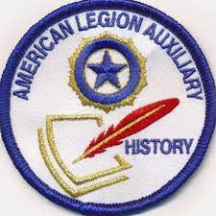

By now you have heard that in 2021-2022, **Mid-Year Reports are not required**. While this relieves Historians of the work to compile a mid-year report, not having this milestone could be problematic. Some may procrastinate and not begin compiling History Books and Reports until the Spring. Waiting makes the task of preparing these reports and the history books feel cumbersome and overwhelming. Also, the story of events may be less accurate than if recorded shortly after the event occurs.

## I ask that all District Presidents ensure that your unit historians receive this newsletter and that you ask them to read page 24 from the February 2018 Auxiliary Magazine – [this link](https://lsc-pagepro.mydigitalpublication.com/publication/?m=9946&i=468803&p=24&ver=html5). While a few years old, the article should be helpful as new unit historians get started or as a refresher for returning unit and district historians. The **2022 “History Senior & Junior Rules”** and **“Historian Annual Reports 2022”** are available on the Department website - Member Resources: <https://www.aladeptga.com/forms-1> Please ask your unit and district historians to review these documents.

To ensure the great things that our members and units are doing, please begin to provide information to Units/Districts/Departments as events happen. Therefore, ask your unit members and unit historians to submit a written account and photographs of events, service, or activities as soon as possible after they happen. The Unit, District, Department, and National Historians will delight in receiving current information.  *“When details are fresh in our minds, it is much easier to present a clear picture of the event.”*

Reach out with any questions you have – email, text, or call.

Ut Prosim!

Cheryl

404-625-6708

[CLWaybright@gmail.com](mailto:CLWaybright@gmail.com)

Full link for the article is: https://lsc-pagepro.mydigitalpublication.com/publication/?m=9946&i=468803&p=24&ver=html5

Hello Everyone,

I would like to take this opportunity to say thank you for allowing me to serve as your ALA Dept. of GA 2nd Vice President and Membership Chair. It was great seeing everyone. Although, I missed seeing my friends who have gone on.

We have a lot of rebuilding to do with membership this year. I want to start off by asking each Units to re-examine your rosters and submit a deceased member form to have those persons removed. By doing so, your member count will be accurate and up to date.

Going forward, I spoke with our Department of Georgia President, Susan Hall and stated I will match National Headquarters membership goal by keeping new member over. Due to the impact, we just incurred with COVID-19, I feel it doesn’t make sense to add the pressure of achieving a goal of 2 extra people with the lost and the decline in our Units membership. However, if you are fortunate to gain those 2 or more new members, Go For It!

I am aware some Units are struggling to keep their Charter going. I plan to look at these Units who are having difficulties and see what suggestions we can come up with ideas to regain your status. Some have come forth with some of their obstacles and I’m looking into tactical steps. Meeting and sitting down with you and putting our heads together would be great, but I will need your help.

Please go on National’s website and register with your Member number. National website: <http://www.alaforveterans.org>. Here you will find in depth detail of 2022 Membership Awards form and many other resources and tools available to you.

**DATES TO REMEMBER:**

Unit Award – 100% Unit Award – Deadline November 21, 2021

Department Award – 75% Award – Deadline December 7, 2021

Department Award – 95% Award – Deadline Poppy Day May 27, 2022

Member Award – 10 New in 2022 – Members must be entered and paid in ALAMIS by June 1, 2022, and received by National HQ by June 3, 2022

Thank you and stay safe!

**Cheryl Jackson-Sinkler**

**770-875-5987**

[**cheryl.jackson0808@outlook.com**](mailto:cheryl.jackson0808@outlook.com)(**NEW EMAIL)\*\***

Department Chaplain

**American Quilt Twin**

**Tickets $1.00 Each or 6 for $5.00**

**Drawing to be held**

**October Fall Conference 2021**

**Proceeds to Benefit**

**Presidents Special Project**

**Fisher House**

**Tickets available through your District President**

**Unit President or Department President**

**Make checks payable to the ALA Department of Georgia**

**Mail check and stub to:**

**ALA Dept. of Georgia**

**3035 Mt. Zion Rd**

**Stockbridge, GA 30281**

By Denise Smith

***Sometimes your Joy can be the source of your Smile, but sometimes your Smile can be the source of your Joy.***

Galatians 5:1 It is for freedom that Christ has set us free. Stand firm, then, and do not let yourselves be burdened again by a yoke of slavery.

Prayer from Eryn Lynum: Dear Lord, I find myself time and time again returning to the confines of this broken world. When I feel trapped in a chained place - somewhere You never intended me to be - show me again the freedom that You bought for me on the cross. Help me to discover, more than ever before, what living in freedom looks like. Amen.

All, remember to let me know of any prayer needs.

My email is [drscpa2@msn.com](mailto:drscpa2@msn.com).

Denise Smith, Chaplain, Dept. of GA



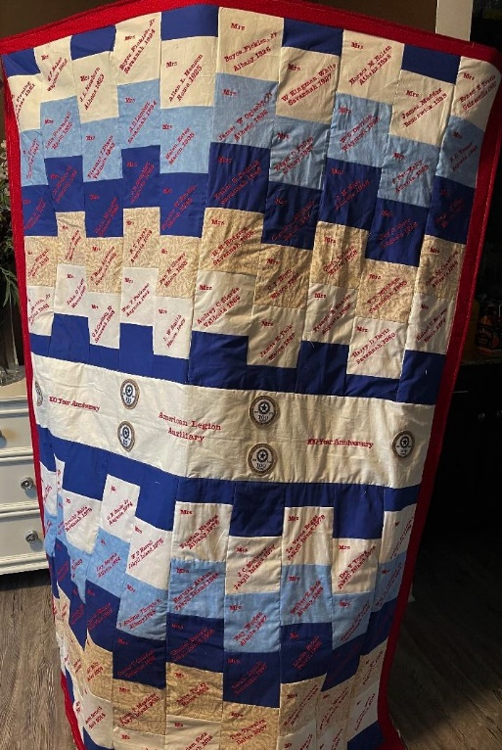

**The 100 Presidents Department of Georgia Quilt**

**Tickets $5.00 Each or 5 for $20.00**

**Drawing to be held**

**Department Convention**

**PPP Luncheon 2022**

**Proceeds to Benefit.**

**50% for PPP Scholarship, 50% Department Headquarters General Fund**

**Tickets available through your District President**

**Unit President or Department President**

**Make checks payable to the ALA Department of Georgia**

**Mail check and stub to:**

**ALA Dept. of Georgia**

**3035 Mt. Zion Rd**

**Stockbridge, GA 30281**





**Calendar of Upcoming Events 2021**

**October is National Breast Cancer**

**Awareness Month**

**October 11, 2021 Columbus Day**

**October 30, 2021 National Trick or Treat Day**

**October 31, 2021 Halloween**

**October 22-24,2021 Fall Conference Sonesta**



**President’s Theme:**

**Shooting For The Stars**

**Membership Theme:**

**Membership of the stars goes all out**

**National President’s Theme:**

**Care for those that care for others**

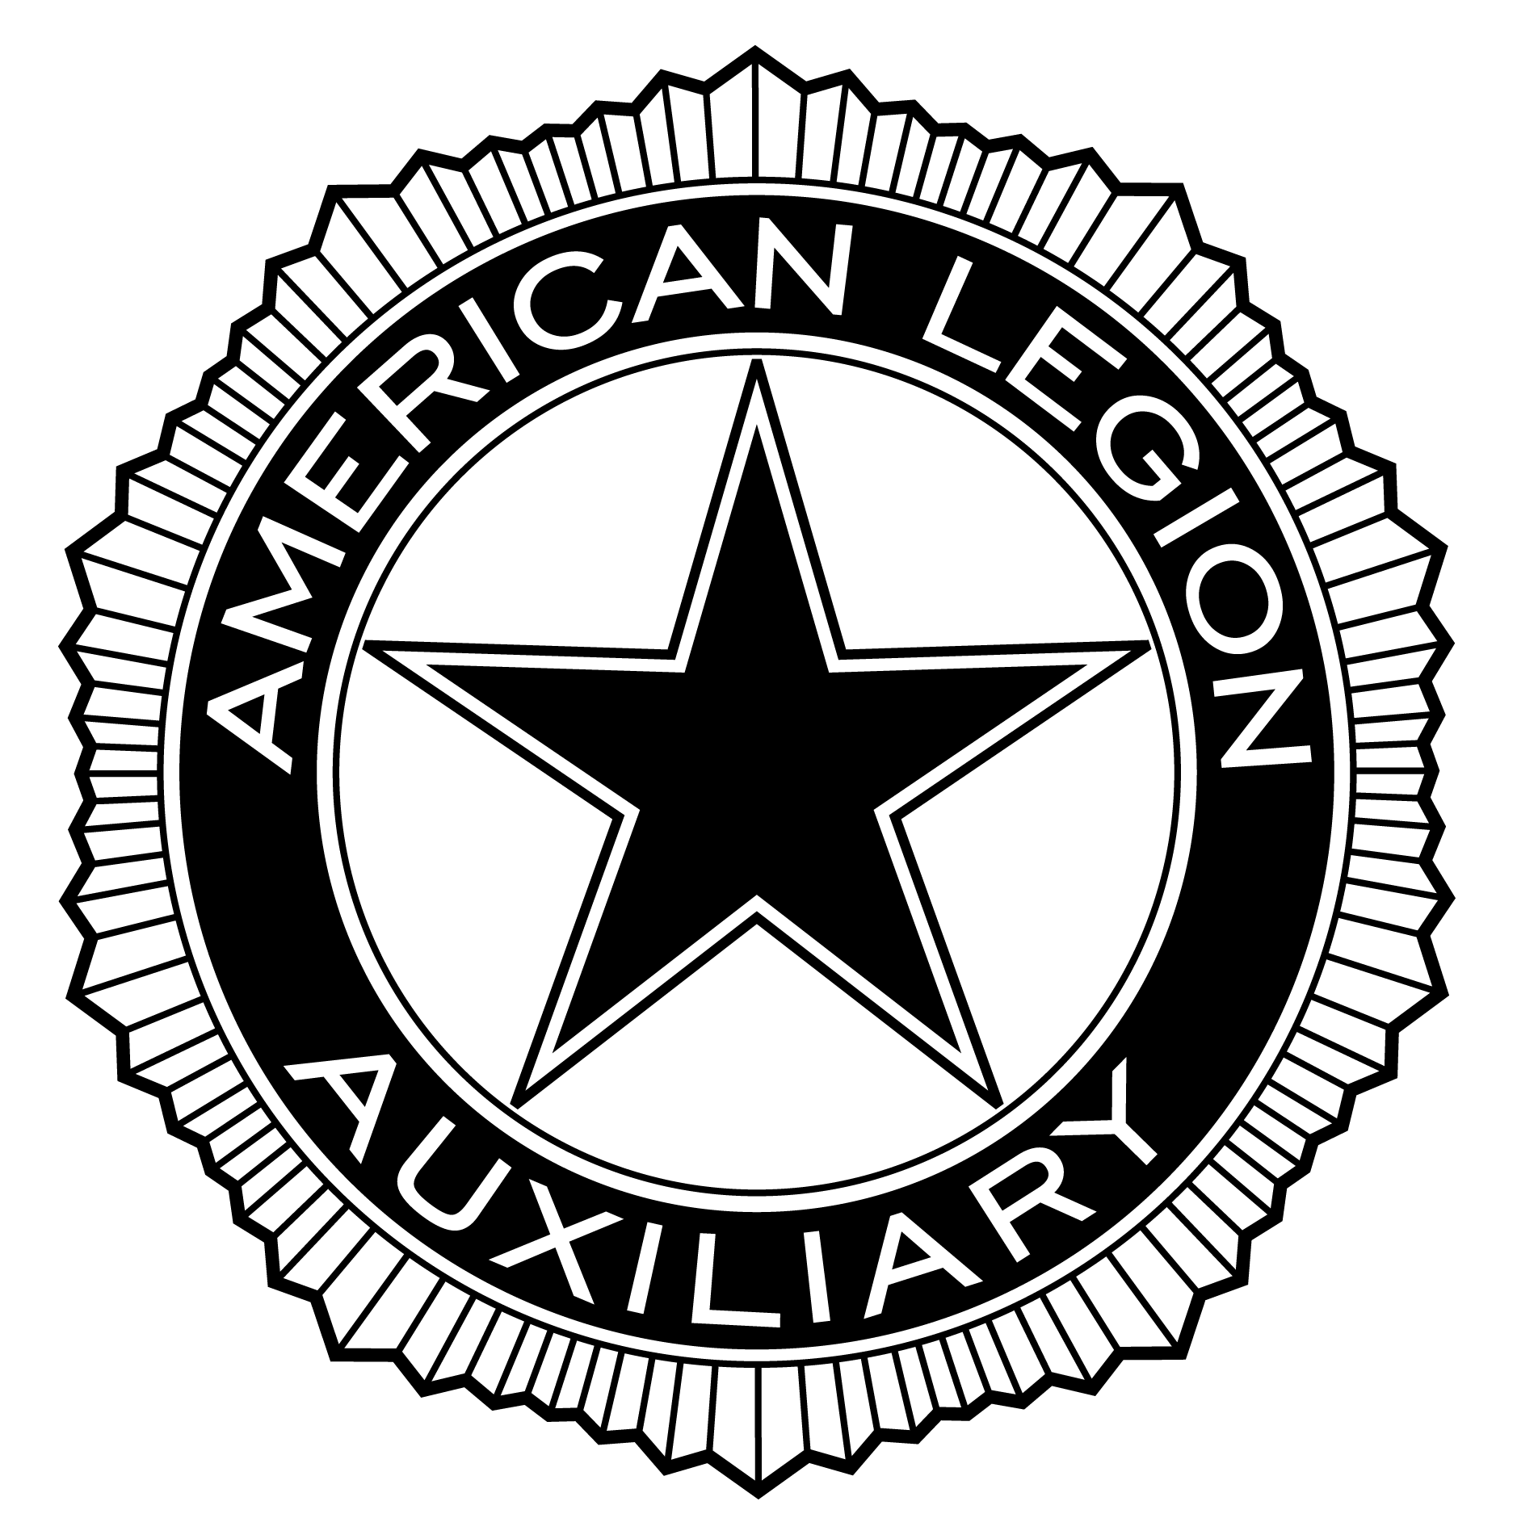

American Legion Auxiliary

Department of Georgia

3035 Mt Zion Rd

Stockbridge, GA 30281

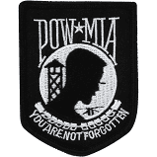

1.
2.